**TASK 17 OUTPUT:**

**1.**

1.Opening the chrome browser

2.Navigates to <http://www.demoblaze.com/>

3.Maximised the browser window.

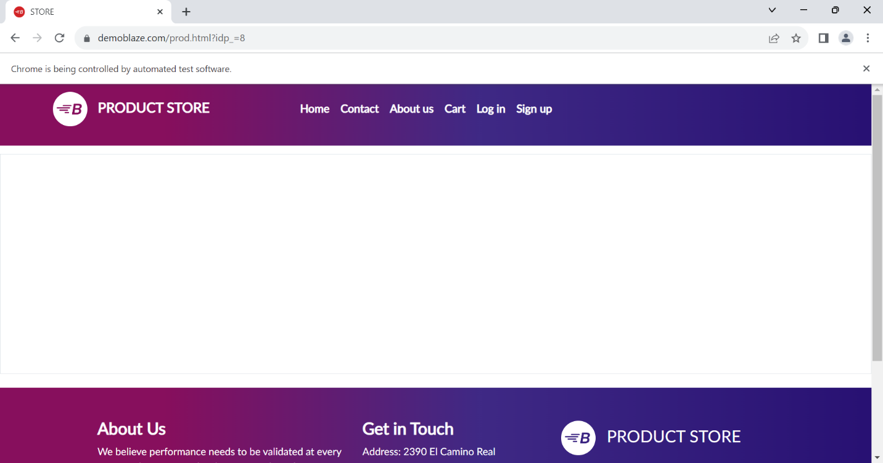

4.Found the element “LAPTOP”.

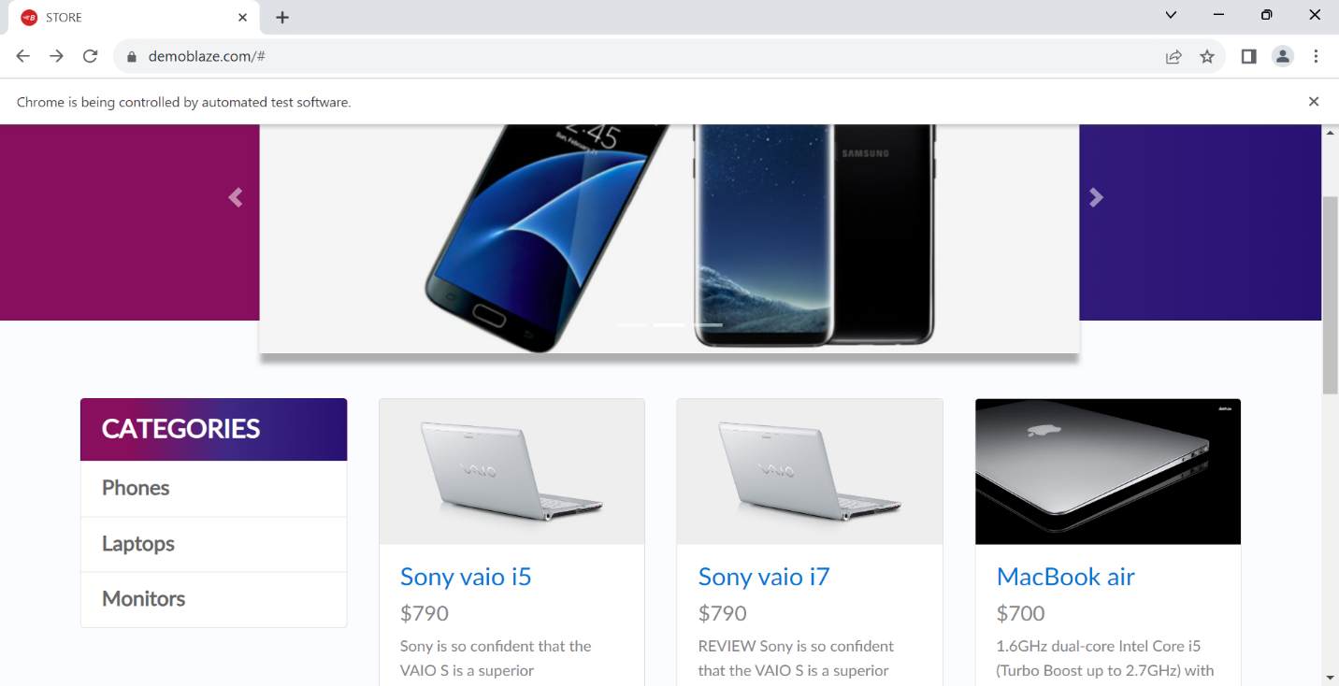

5. Clicked on “Sonia via i5’ laptop .

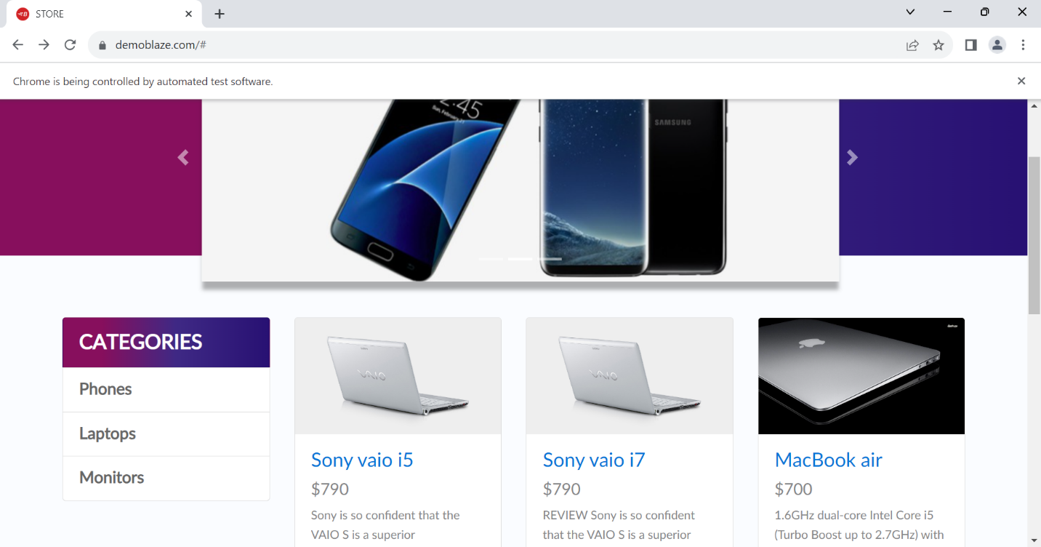

6.Item is added to cart.

